|  |  |
| --- | --- |
| **Name** | **Yash Shinde** |
| **NUID** | **001493321** |
| **Course** | **DWBI Online** |
| **Assignment** | **13 (SSAS)** |

**SQL Server Analytical Services exercise.**

* First, we pulled Adventure Works 2017 DW from SSMS to SSDT (visual Studio) since Analytical services were not installed properly in the first go, we rectified the installation error.
* Once, created a new project in SSDT called HW13 SSAS exercise.

1. Under this project I have created as follows:
2. Data Sources
3. Data Sources Views
4. Cubes
5. Dimensions
6. Later These dimensions are processed according to the need and exported into an excel file which shows pivot tables of the work.

**1. Data Sources:**

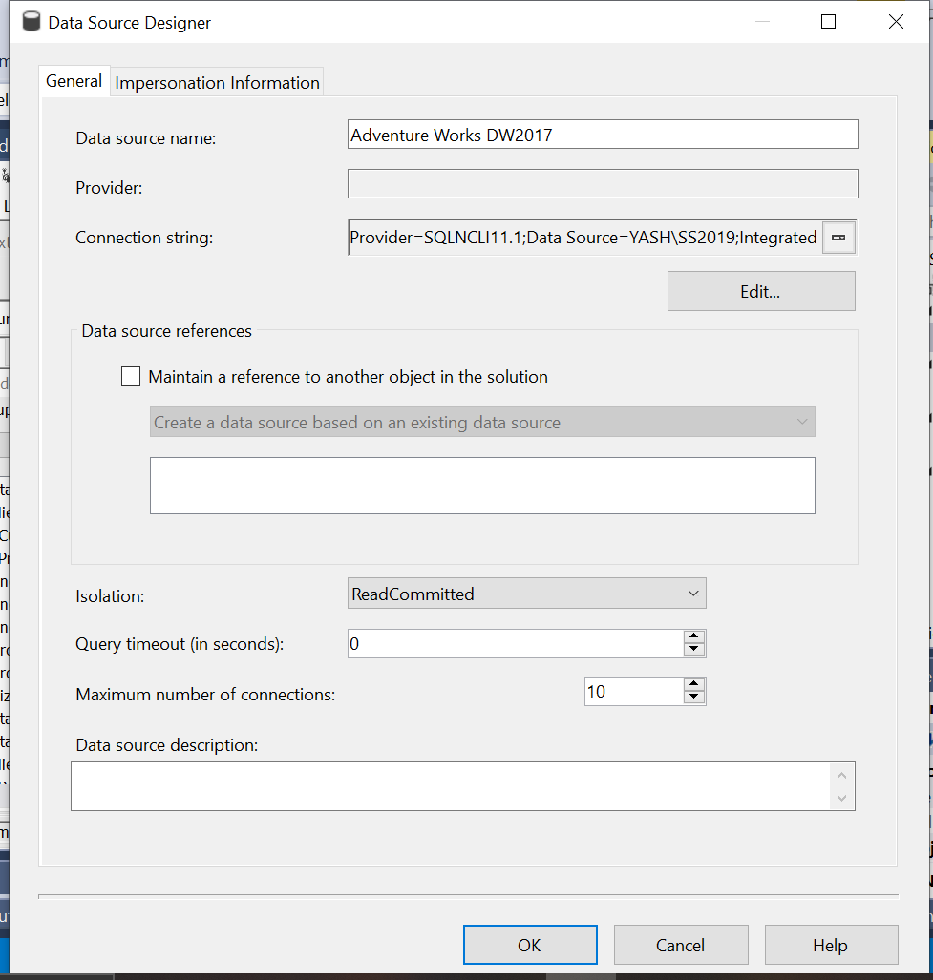We have used the services account to create a data source to select ‘Adventure Work DW2017’ from SSMS

**2. Data Source Views:**

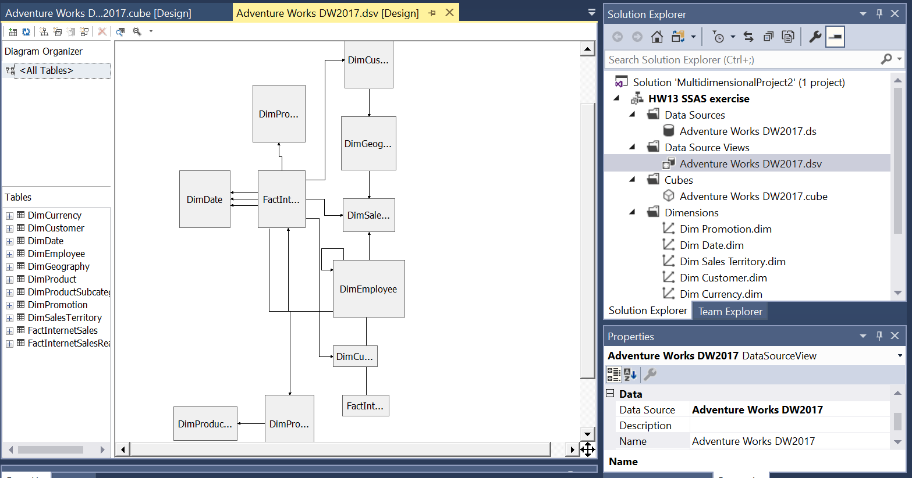

By selecting required columns from tables of Adventure Works DW2017 we have created the schema ensuring all the connections yields no error.

**3. Cubes:**

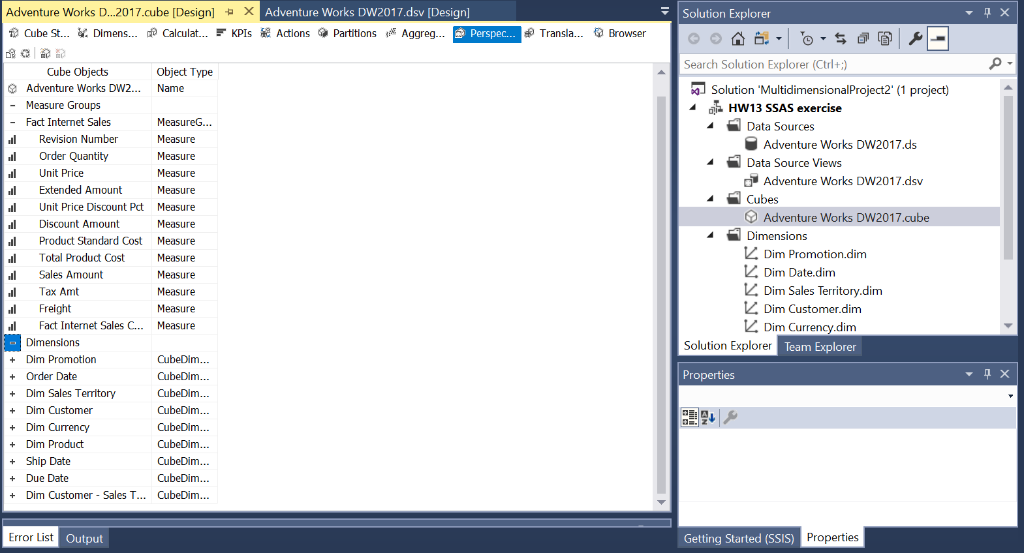

**4. Dimensions:**  
We have selected 6 dimensions for this analysis.

* + **Production**
  + **Date**
  + **Sales**
  + **Customer**
  + **Product**
  + **Currency**

**Production Dimension:**  
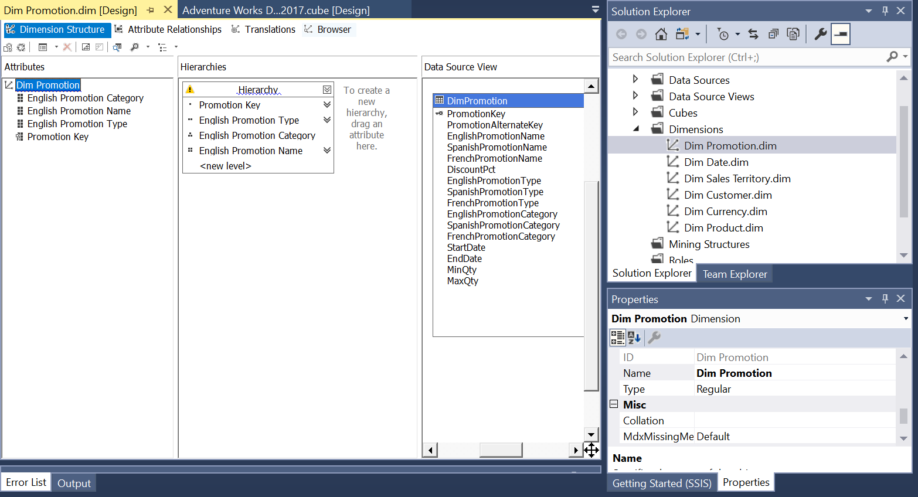

In this screenshot, we can see how attributes are pulled from attributes view and arranged by hierarchies.



Attribute relationship is maintained by connecting the attributes according to the hierarchy and presence of attributes in a table.

Correct properties are assigned, by selecting correct column name

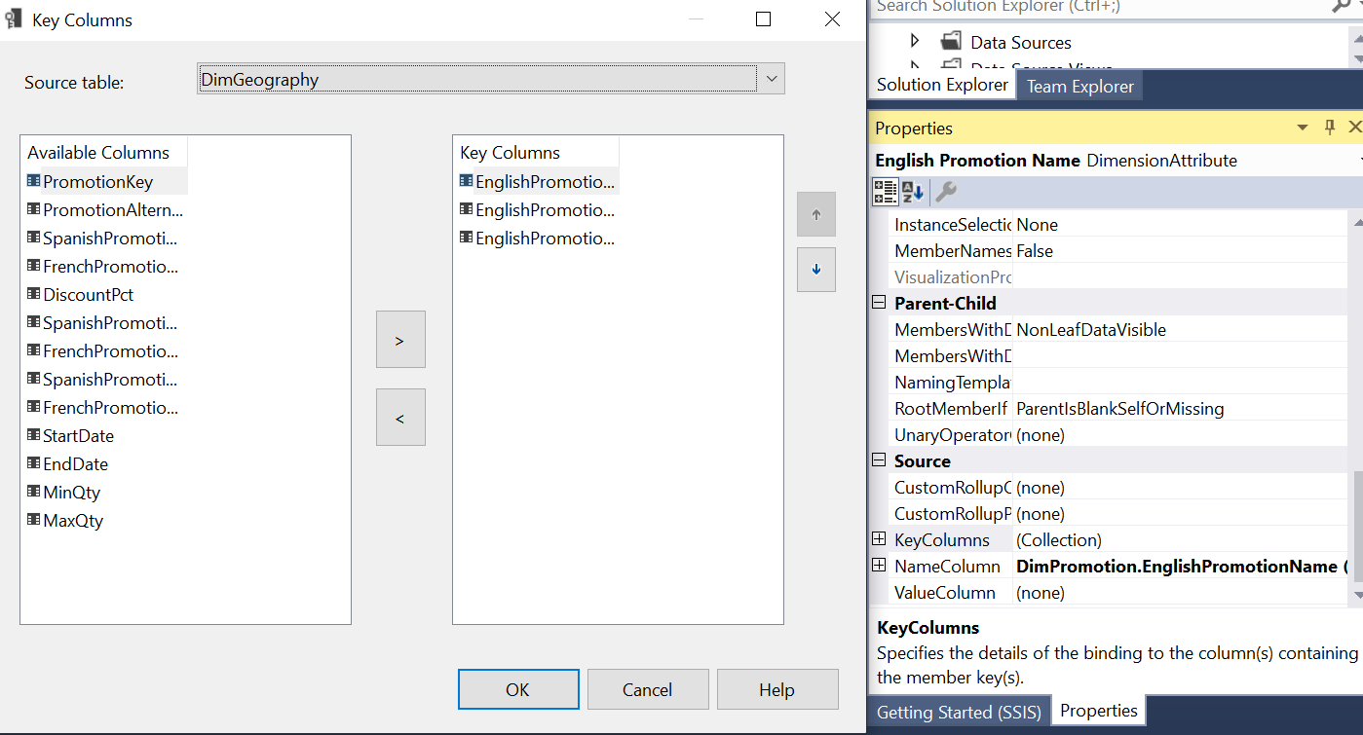

Under source, Key column and Name column are assigned according to the sequence in attribute relationships.

Post this step, the dimension is processed (executed) and once done, cube is executed and saved in an excel format which looks as follows:  
  
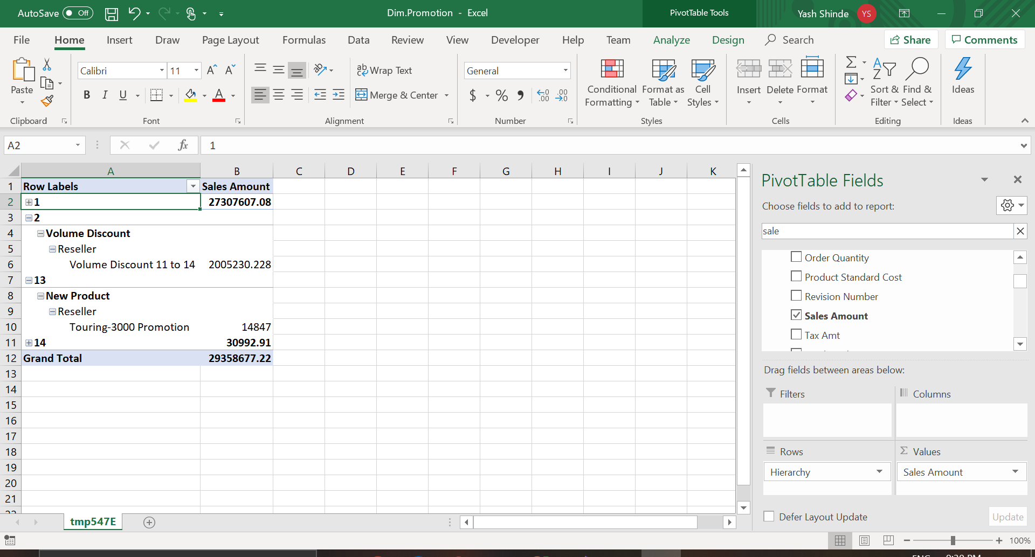

This table shows columns values as presented in hierarchy.

**Dates Dimension:**  
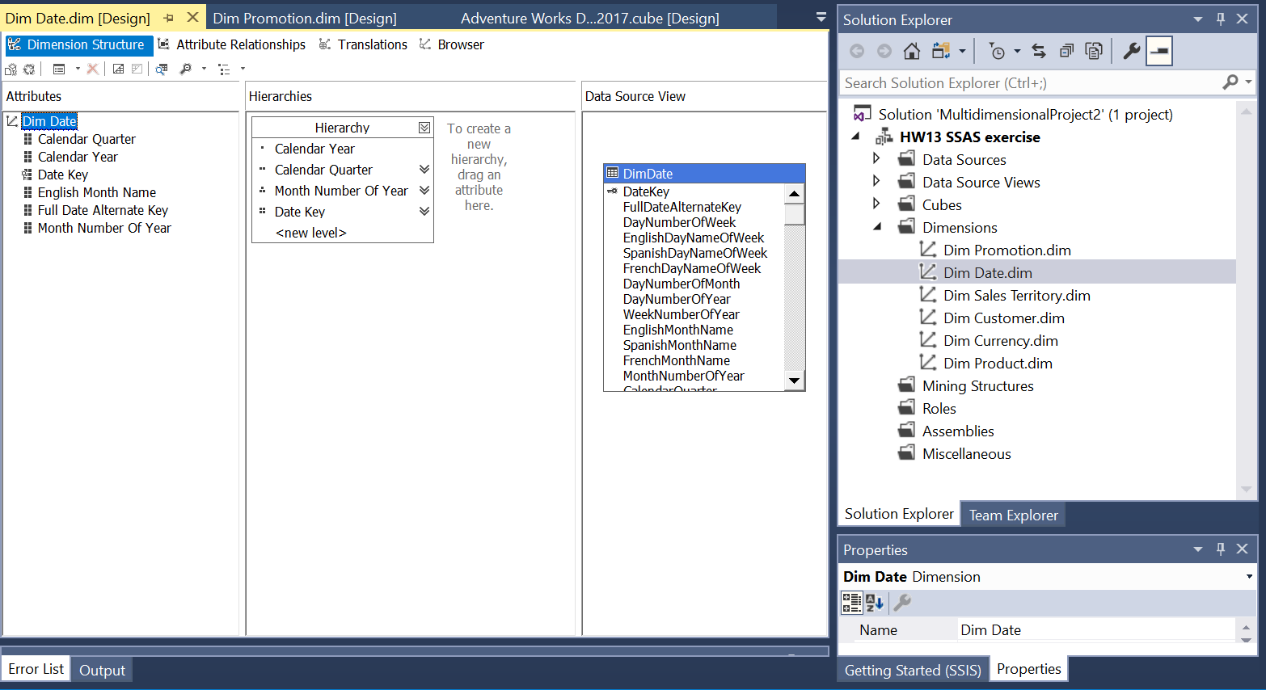

In this screenshot, we can see how attributes are pulled from attributes view and arranged by hierarchies.

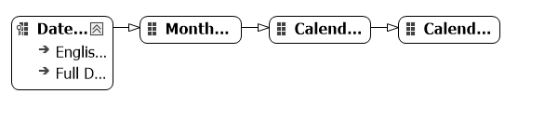

Attribute relationship is maintained by connecting the attributes according to the hierarchy and presence of attributes in a table.

Correct properties are assigned, by selecting correct column name 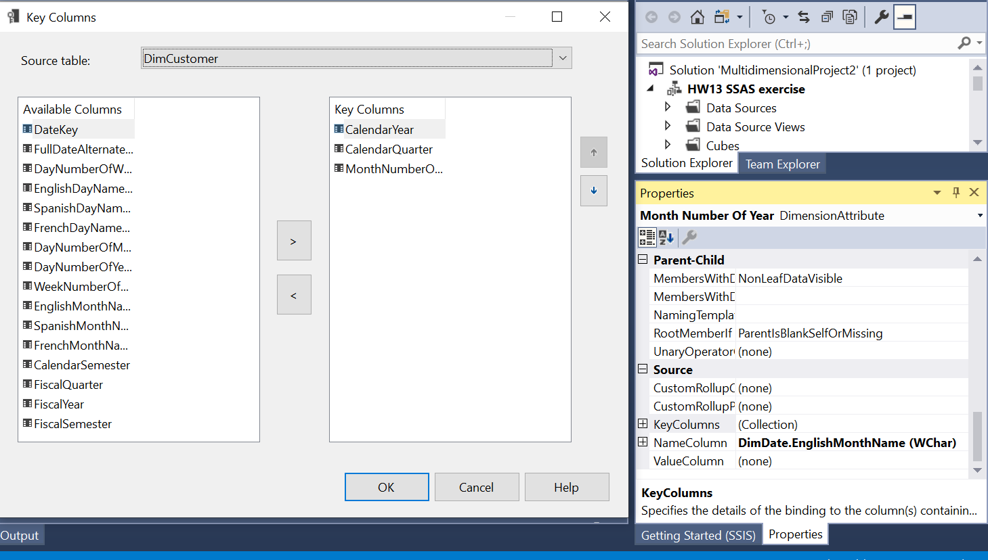

Under source, Key column and Name column are assigned according to the sequence in attribute relationships.

Post this step, the dimension is processed (executed) and once done, cube is executed and saved in an excel format which looks as follows:

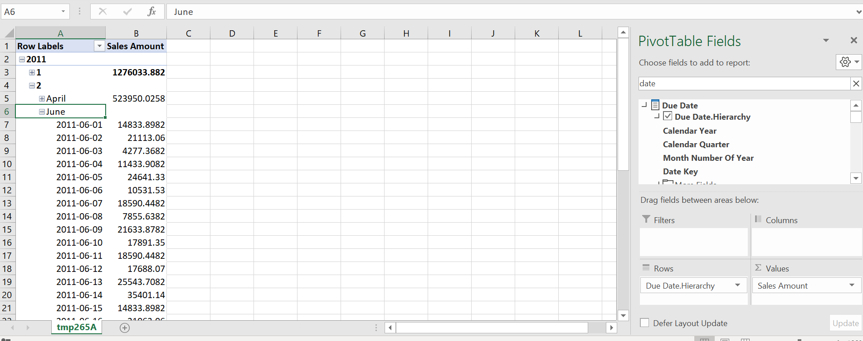

**Sales Territories:**  
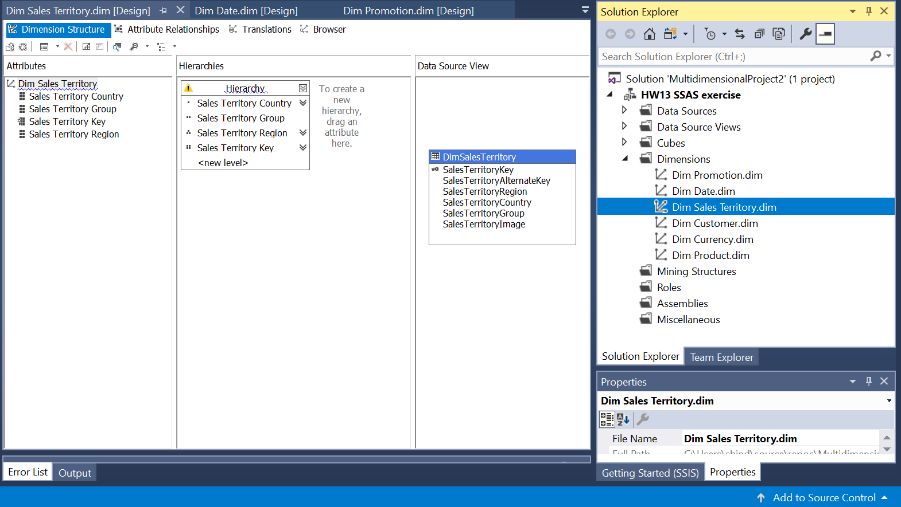

Under source, Key column and Name column are assigned according to the sequence in attribute relationships.

Post this step, the dimension is processed (executed) and once done, cube is executed and saved in an excel format which looks as follows:



Attribute relationship is maintained by connecting the attributes according to the hierarchy and presence of attributes in a table.

Correct properties are assigned, by selecting correct column name

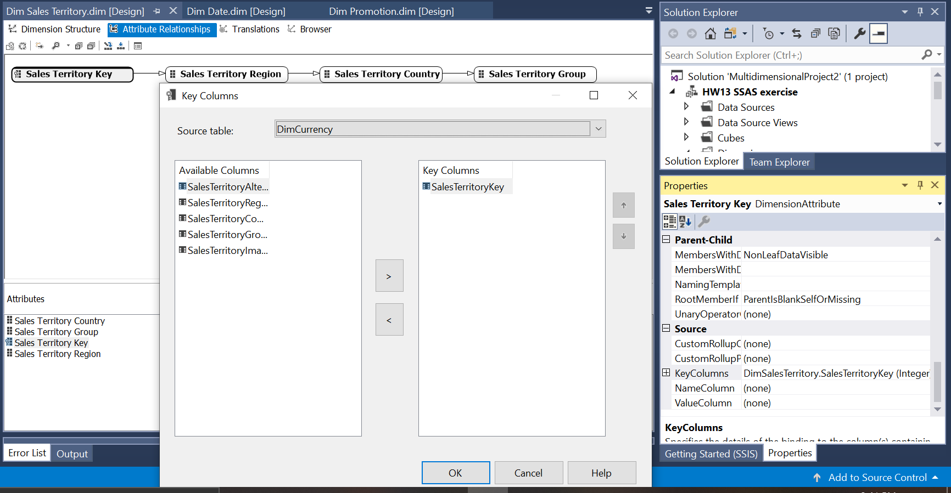

Under source, Key column and Name column are assigned according to the sequence in attribute relationships.

Post this step, the dimension is processed (executed) and once done, cube is executed and saved in an excel format which looks as follows:

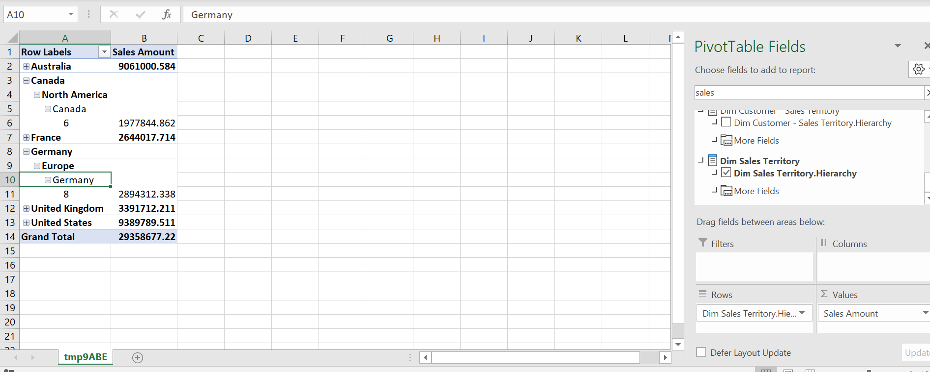

**Customer Dimension:**  
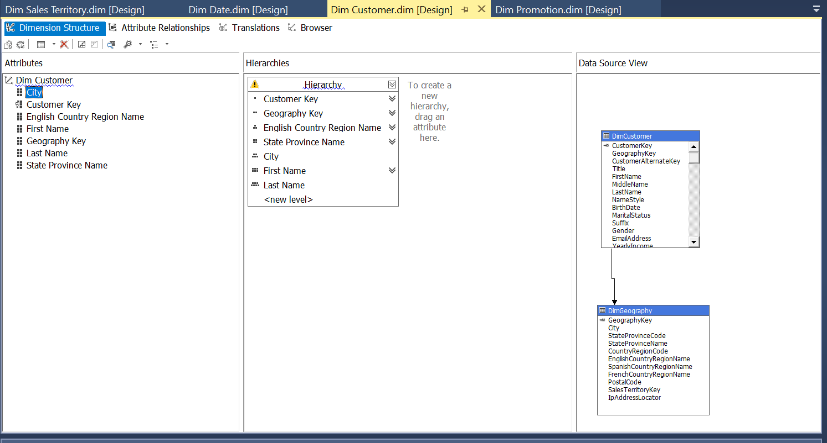

Under source, Key column and Name column are assigned according to the sequence in attribute relationships.

Post this step, the dimension is processed (executed) and once done, cube is executed and saved in an excel format which looks as follows:



Attribute relationship is maintained by connecting the attributes according to the hierarchy and presence of attributes in a table.

Correct properties are assigned, by selecting correct column name

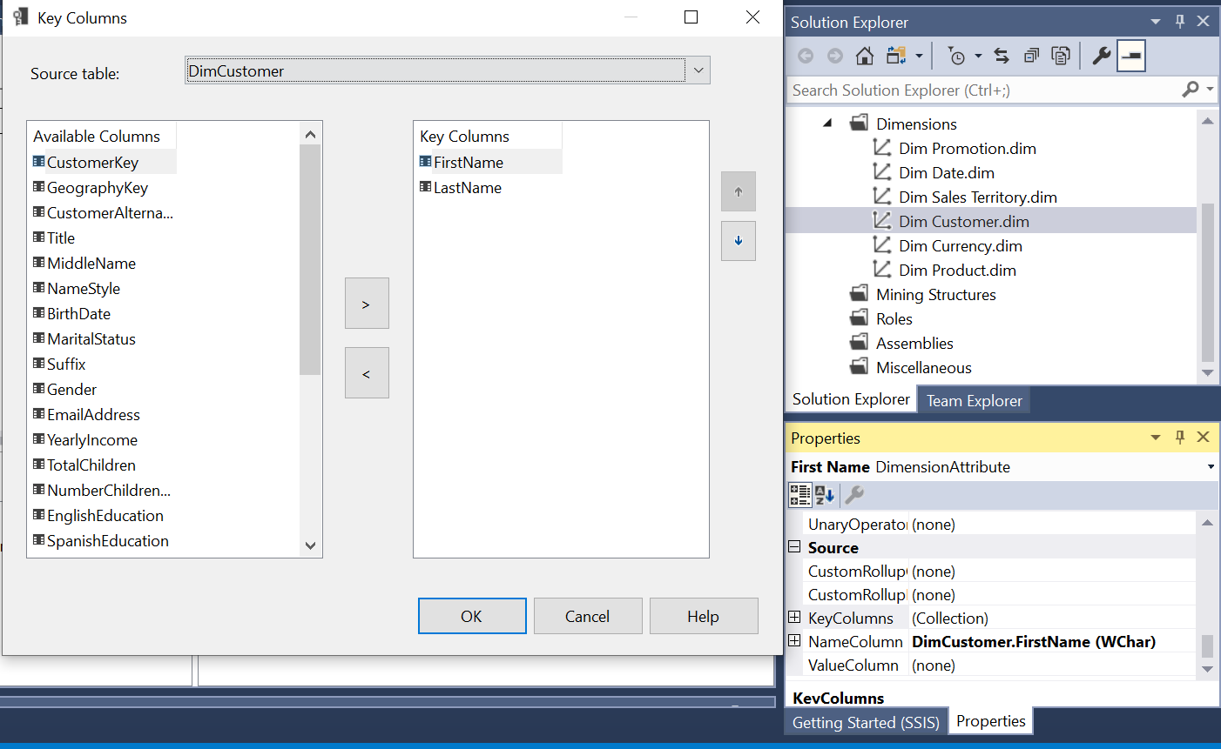

Under source, Key column and Name column are assigned according to the sequence in attribute relationships.

Post this step, the dimension is processed (executed) and once done, cube is executed and saved in an excel format which looks as follows:

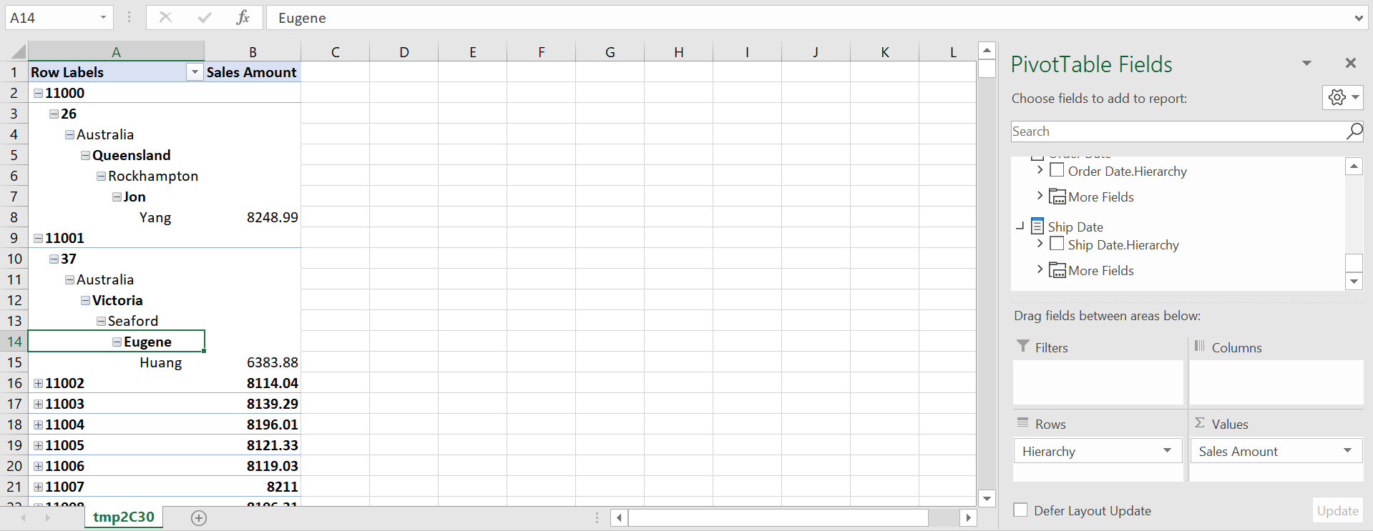

**Product Dimension:**  
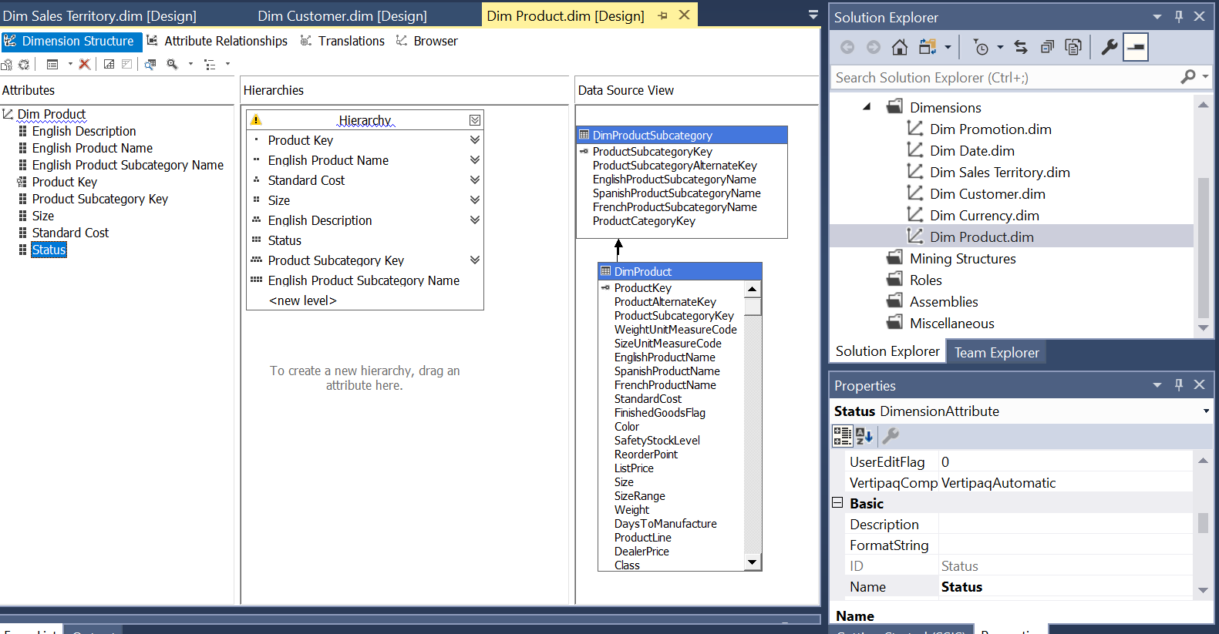

Under source, Key column and Name column are assigned according to the sequence in attribute relationships.

Post this step, the dimension is processed (executed) and once done, cube is executed and saved in an excel format which looks as follows:



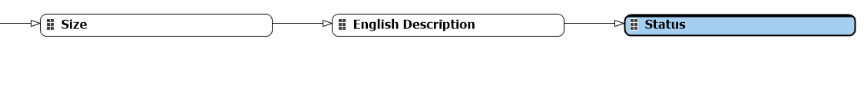

Attribute relationship is maintained by connecting the attributes according to the hierarchy and presence of attributes in a table.

Correct properties are assigned, by selecting correct column name

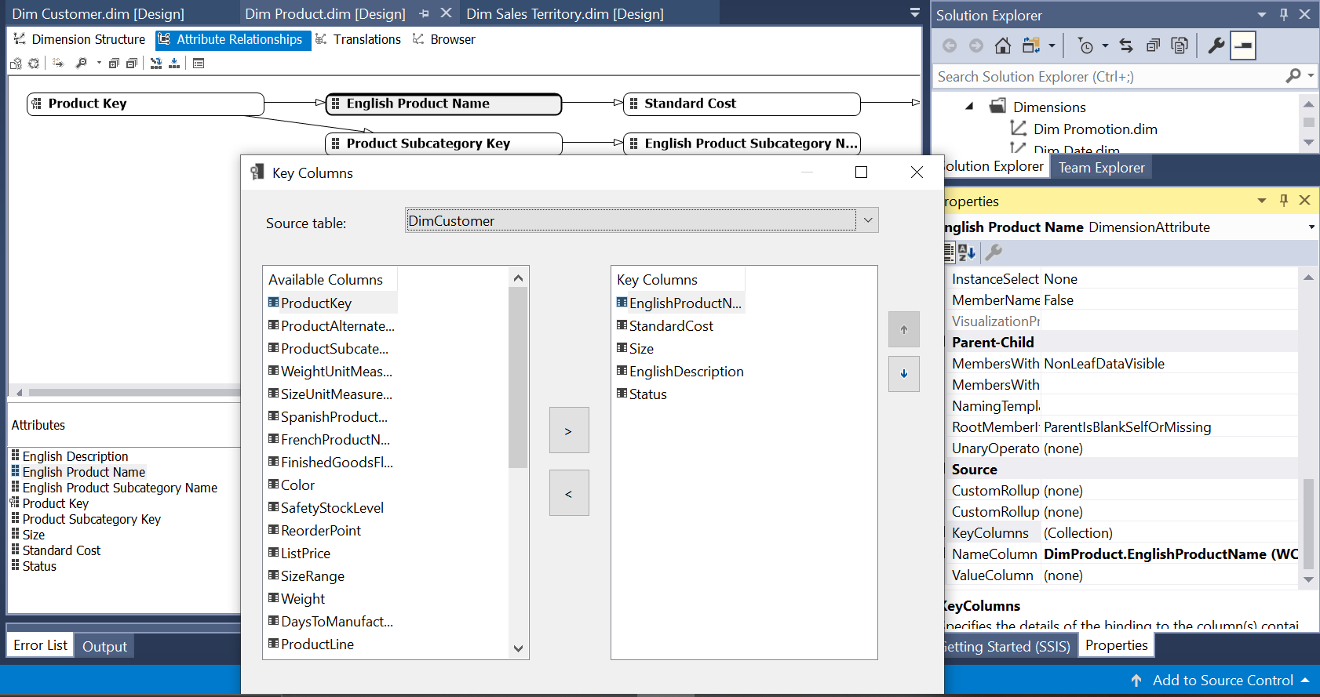

Under source, Key column and Name column are assigned according to the sequence in attribute relationships.

Post this step, the dimension is processed (executed) and once done, cube is executed and saved in an excel format which looks as follows:

